“Do not store up for yourselves treasures on earth, where moth and rust consume and where thieves break in and steal; but store up for yourselves treasures in heaven, where neither moth nor rust consumes and where thieves do not break in and steal. For where your treasure is, there your heart will be also.”
Matthew 6:19-21

Thank you to all who gave their 2020 financial pledges.
Your support helps North Presbyterian Church be the wonderful, loving community of the people of God that truly makes a difference in the lives of our church members, friends, community and world. If you have not yet given your pledge, you may pick up a pledge card in our church office. It is very helpful to know what every church member and friend's pledge is for the coming year as we make plans for the best use of our gifts.
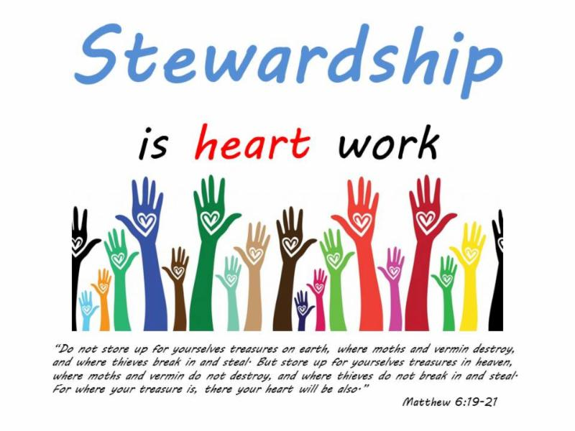
Thank you!

